Problem Statement
Application is running fine in development environment but not working in QA environment.
Reason:
- Different versions
- Dependencies

How to ship application in to different environment,
Environments (o/s, java, and tomcat) must be ready before deploying the artifacts (.war), we just move artifacts from one environment to another environments.
Configuration Management tool (Ansible) help us to environment setup and deploy application in different environments.
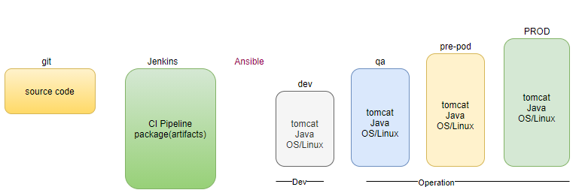
Problem: Environment (O/S, java, tomcat) already pre-configured before shipping, and in every release, we just shifting the artifact (.war). What about the dependencies? Cause may be mismatch in configuration (java level, O/S level, tomcat level) in various environment.
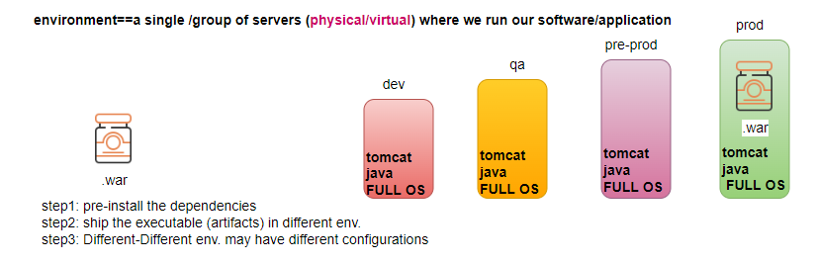
Solution? Container
Container: Is a package that consist of an app/software + all of its dependencies bundled together and deliver this package different environments
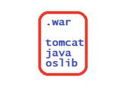
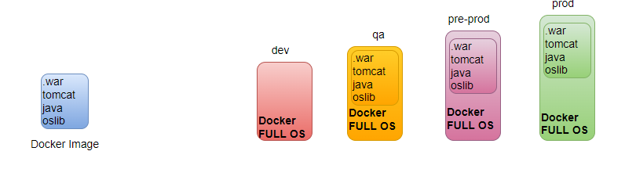

How to build and run the container?
What is the tool used to build .war (MAVEN), we convert the source code into a single executable file, similarly we need a tool to create a package (bundle artifacts and its dependencies in a single package) i.e., a containerization tool/container run time
- helps to build container package (Image)
- helps to run/deploy the containers
ex: docker/containerd/lxc/rocket/crio/podman
Docker is a tool help us BUILD the container->SHIP the container in different environments-> also RUN the package as a container.
Technically package is called the docker image, run time instance of the image is container. We can create multiple instances from a single image.
Docker Image:
- Is a software package sitting on your disk using the disk space
- We copy the image/ install on server
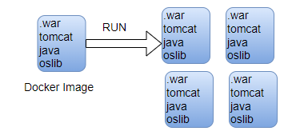
Docker Container:
- Container is runtime instance of an image.
- Container is just a process that run inside your computer/ server (physical/ vm) and consumes the resources (cpu/ram).
- From a single image we can run n number of containers
- Image is just like a car in parking mode (engine is in stop state). Image requirement is just a storage to store the File System just like car parking to store it filesystem, don’t need to allocate any resources to the image, docker take care at run time Dynamic allocation of the resources.
- Container is like a car in running mode (engine is in running state use fuel and resources), container requirement is CPU and RAM (Memory).
- When you start the car now engine is in starting mode which solves the purpose of car-> container. When car starts it consume petrol, similar when container runs it consumes some resources like CPU and RAM.

Docker-Architecture
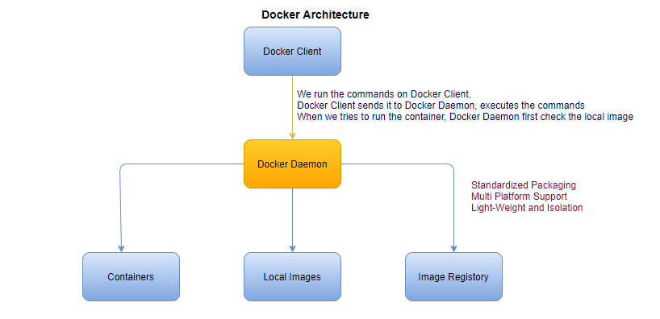
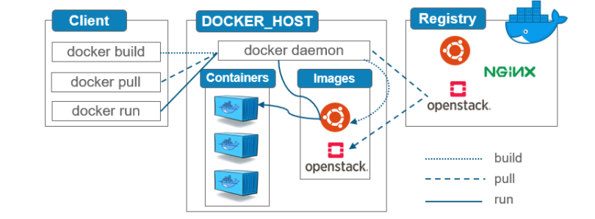The docker client and daemon run in separate environments
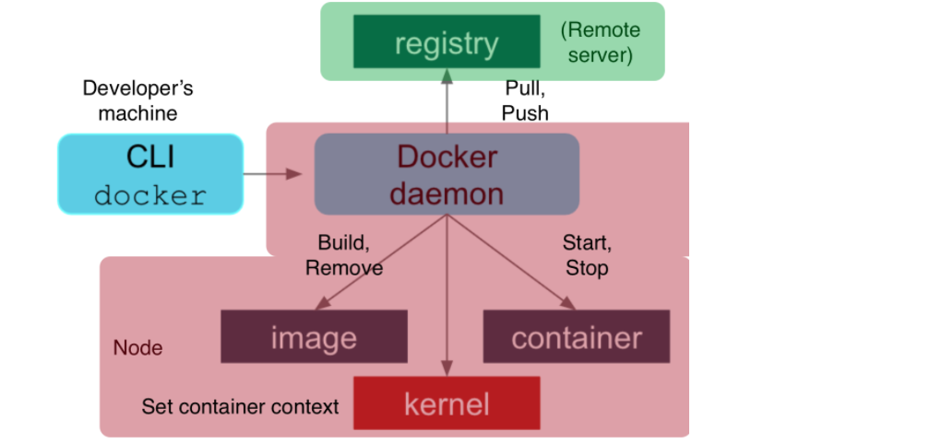
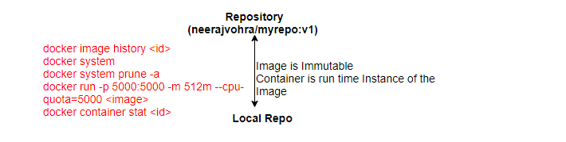
How docker really works behind the scenes?
Where namespace, group and UnionFS is used in docker?
Namespace is responsible for isolation b/w the containers. Type of namespaces are PID, n/w, User, filesystem and so on (processId)
Cgroup is responsible for resource management or resource limitation in each container CPU, mem, Network and I/O.
UnionFS is a filesystem service which is used for creating docker image layer.
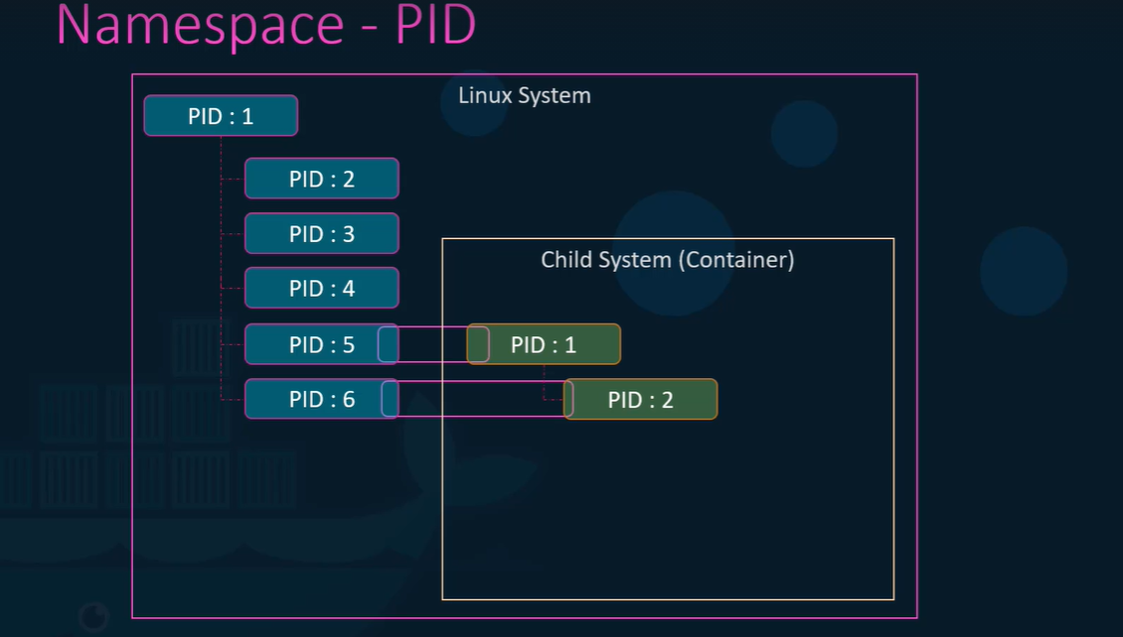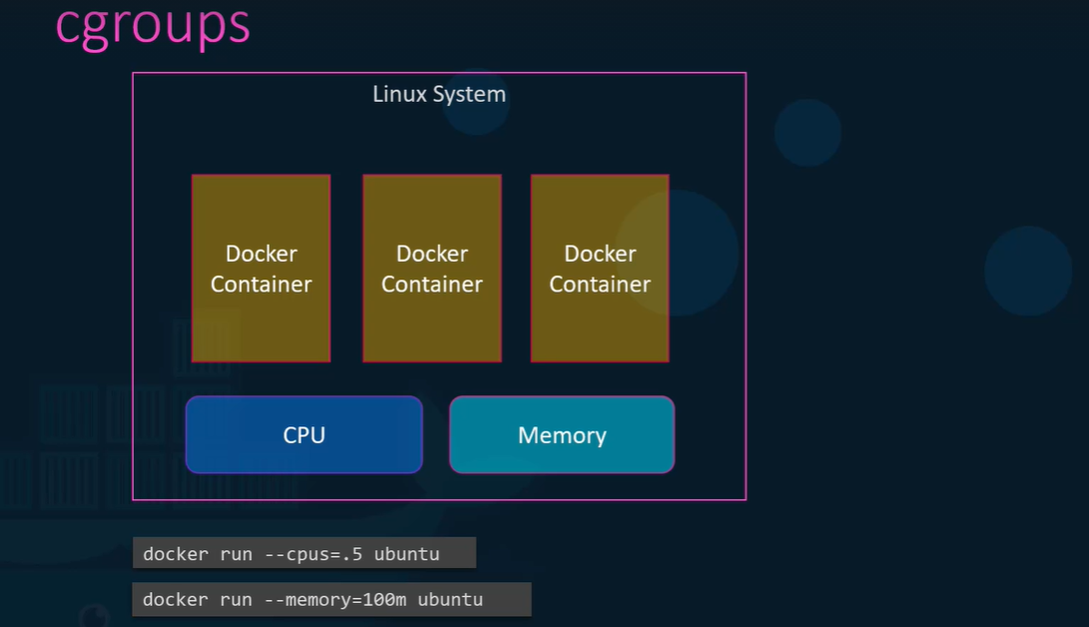
ps –eaf # all the processes running inside the container
Is container replacement of VM?
No, container can be run on physical machine or on top of the VM.
If we have to run different-different applications then go for VM, if we have to execute multiple replicas of the same application then go for containers.

If your application is heavy then go with VM.
To Run the package in different environment we don’t require any configuration on any environment, just docker installed on the environment no configuration required.
docker is open source by default - free docker-ce
docker also provides licensed s/w- paid docker-ee
Difference between Physical, VM and Container
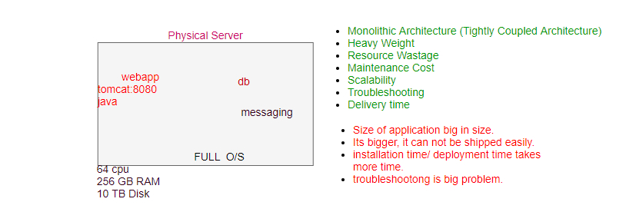
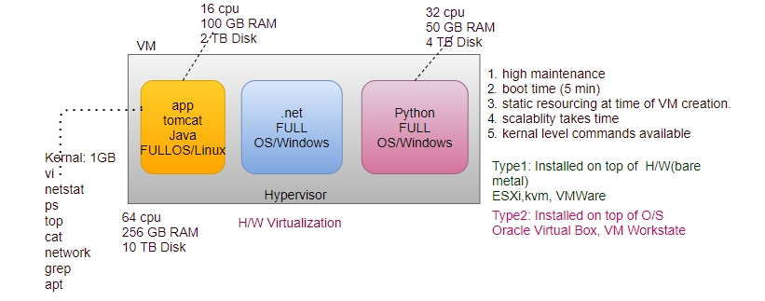
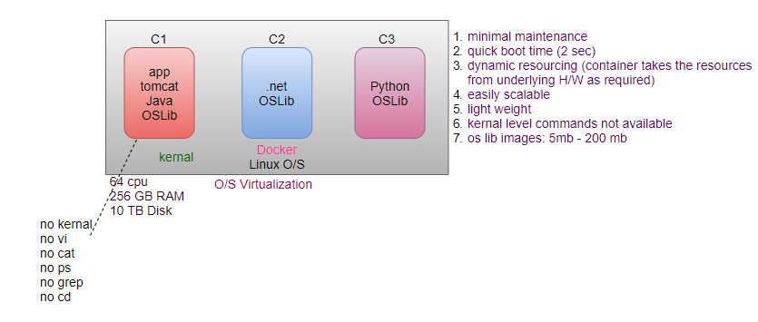
In VM, we split the H/W resources in smaller pieces, Every VM provided a set of dedicated H/W resources. (H/W Virtualization, O/S level Isolation)
Every VM have full O/S.
Every VM have own IP address.
To run a container we need a machine, with a Full O/S either a physical machine or a VM, on top of that install Docker.
Every container has own IP address.
O/S Virtualization, App level Isolation
Difference between Full O/S and O/S lib (don’t have dedicated kernel)?
- Minimum O/S (O/S lib) never requires license, they are open source and free.
- When we create a container, we don’t allocate any resource to the container, because container is just a process running on your system, and process can take any resources from underline H/W as required. It’s a docker which provides necessary resources to the container dynamically. Docker talks to the O/S kernal feature to provide the necessary resources to the container, then kernal talks to the H/W.

Installation
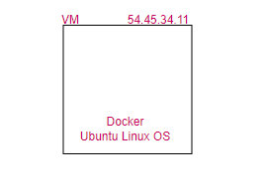
docker -v
/var/lib/docker
service docker status
To run a container what we need?
docker image: We will use some publicly available images from official docker image repository and run container from it.
Once we understand about how to run container completely from given image then we will learn about how to build our own images.

Where we get the Images?
dockerhub to get the public images. Dockerhub has default account library.
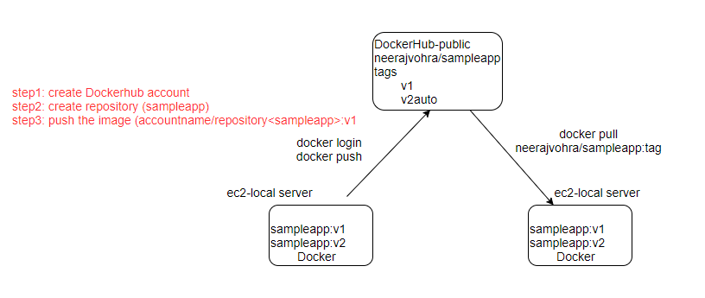
docker image ls # to see if there is any image in system
docker pull tomcat
docker pull nginx
docker image ls
/var/lib/docker
ls -l
docker image rm <ID>
cat /etc/docker/daemon.json # default dockerhub
What is Docker Image?
- A docker image is a read-only template that contains source code, libraries, dependencies and set of instructions for start a container.
- docker image is immutable
What is Docker Container?
- container is running instance of the image.
- Every time you start a new container, an extra writable layer is created for it, where it stores the container specific changes.
- Changes are done on container, not on image (immutable)

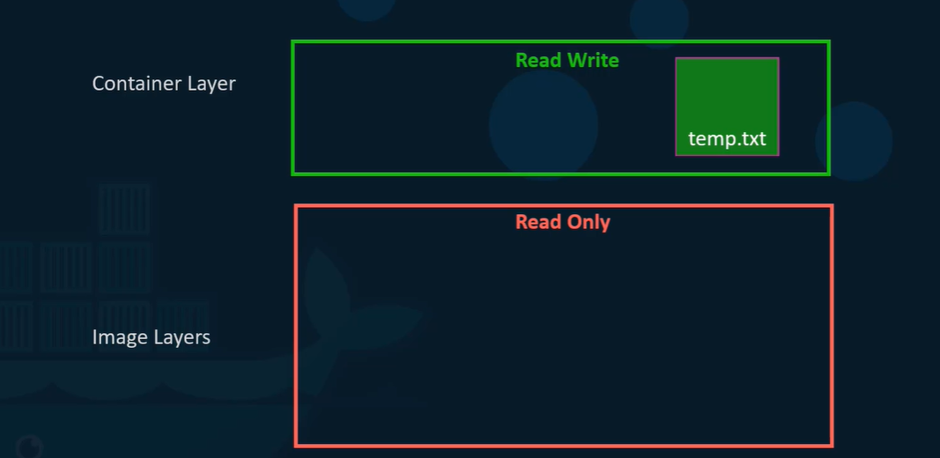
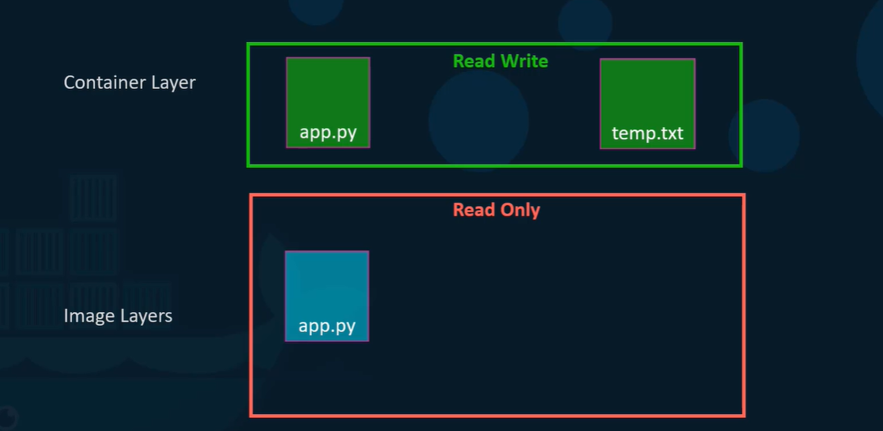
COPY_ON_WRITE
How to run container from a given image?
To create/run a container from a given image we always use docker run command
Two Methods:
Interactive mode (-it)/ foreground # default
Whenever you want to interact with container O/S to validate what is inside? Or to make changes inside the container (dev use case)
docker run image:tag
docker run -it tomcat:latest bash
to come out of container always use ctrl pq
Container has a shell, if we have to interact with container we must have to go inside the container.e.g. We want to check the java version inside the container, or want to make some changes inside the container, in those cases we must have to interact with the container. Customization (on top of the base image).
detached mode(-d) / background
To run a container in background mode (production use case)
docker run -d tomcat:latest
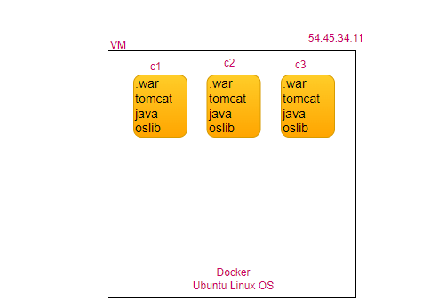
How to know status of the container?
docker container ls # docker ps all running container
docker container ls -a # all containers running and dead
container is just like a human body, processes inside the containers are just like a heartbeat of human body if there is heartbeat in human body then its living body, without the heartbeat human body is dead body similarly if there is no process inside a container, container just goes into dead state (exit (0)).
docker run -it <image> bash
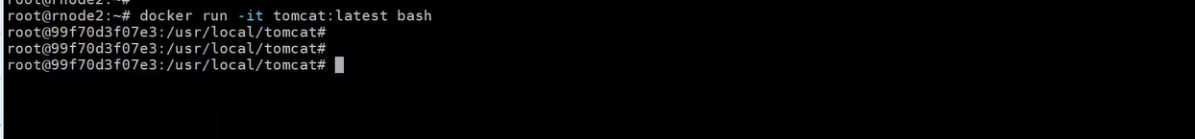
# ctrl pq
How to get details of the container?
docker container inspect <container-id>
Container Lifecycle
- created
- running
- stop
- restart
- kill
- remove
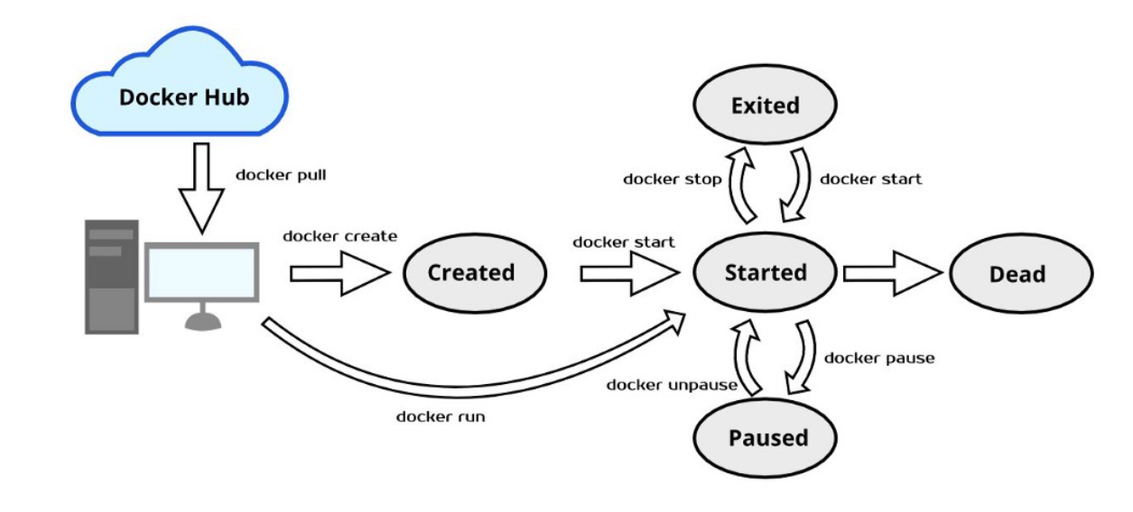
First create an Image, create a container from Image, container may be in running state or in exited state. If in running state can be stopped, restarted, kill can be removed.
docker run nginx # foreground
docker run -d nginx # background
docker ps # shows all running containers on your server
docker stop <CONTAINERID>
docker ps -a # shows all running/stopped containers on your server
docker restart <CONTAINERID>
docker kill <CONTAINERID>
docker rm -f <CONTAINERID>
docker stat # CPU/Memory Utilization
docker logs -f <CONTAINERID> # follow live logs
docker inspect <CONTAINERID> # detailed information of container bridge network, dynamic IP
/var/lib/docker/container
curl <IP> # command line browser
free
free -m
Difference between docker stop and docker kill?
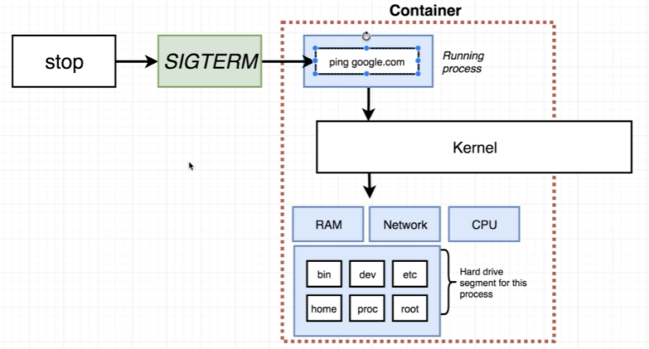
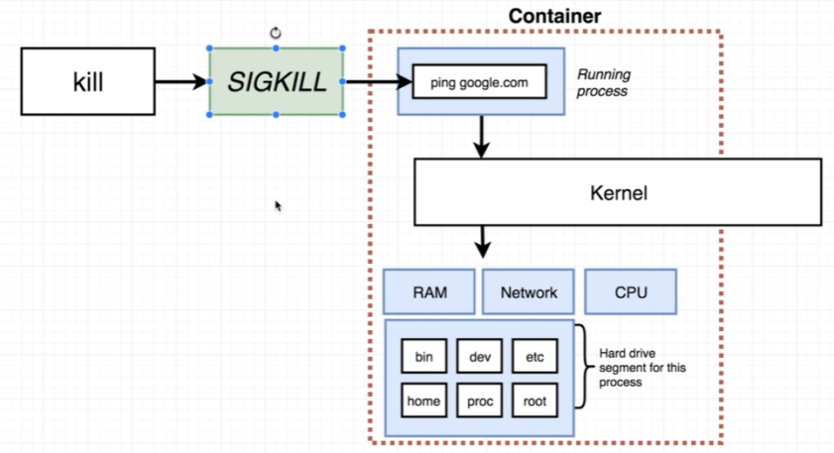
How to get inside the running container?
We can login to a container only if it is up, docker exec helps to login to a running container.
docker exec -it <containerId> bash
How to execute command inside the running container without getting inside?
docker exec <containerId> ls-l
docker exec <containerId> cat /etc/os-release
docker exec <containerid> java -version
docker exec <containerId> netstat
# Will fail (O/S lib, default features of O/S not available)
Why you want to go inside the container?
Want to customized, want to know version of java running inside tomcat container etc.
How to access the application running inside the container from the outside?
Port Publish
How to publish the port?
docker run -d -P <image> # P dynamically allocate the port
docker run -d -p 9090:8080 <image> #p <host>:<cont>allocate port statically
docker run -d -P lerndevops/samples: mywebsite-v1
containerip:containerPort
- can never be used in browser
- they internal only (can access only inside the server where the container is running)
browser: vmip(ec2ip):port
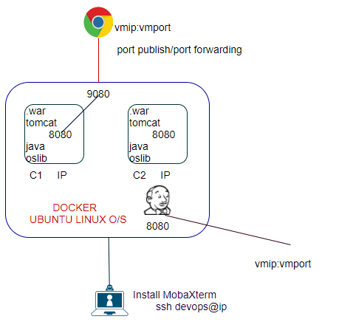
How to customize container name?
docker run -d --name <neeraj> <image>
How to rename container name?
docker rename <old name -clever_yonath> <new name- neeraj>
Advanced Container Commands
limit-container resources
docker run -d -P --cpu=”.5” nginx
docker run -d -P --memory 500M --memory-reservation 256M nginx
How to build own docker image?
- manual process
- automated process

Manual Process: creating an Image from container change
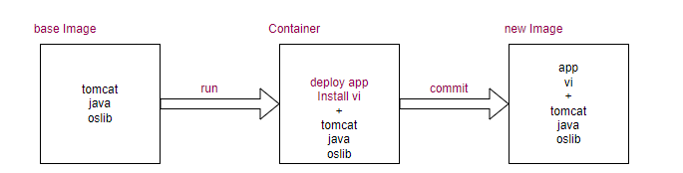
step1: take a base image (any image from Dockerhub)
docker pull tomcat:8.5.45
step2: run it as a container
docker run -d tomcat:8.5.45
step3: login to the container
docker exec -id <containerId> /bin/bash
step4: Inside the container make changes
/usr/local/tomcat
cd webapp
wget https://github.com/lerndevops/code/raw/main/sampleapp.war
#docker cp sampleapp.war container_id:/usr/local/tomcat/webapp/sampleapp.war
apt update
apt install -y vim
exit # logout the container ctrl pq
step5: Validate container still running
docker ps
step6: Create a new image
docker commit -m "any msg" <containerId> newimage:tag
step7: validate the newly created image
docker image ls
step8: Validate the Changes
docker run -d -P <Sampleapp:v1>
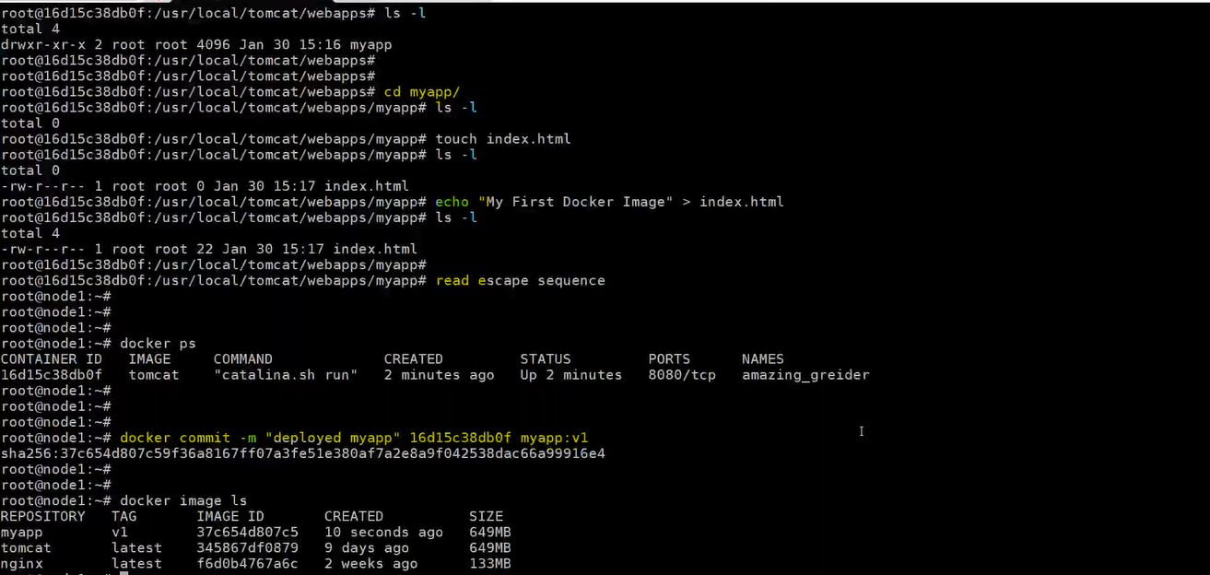

Automated Process
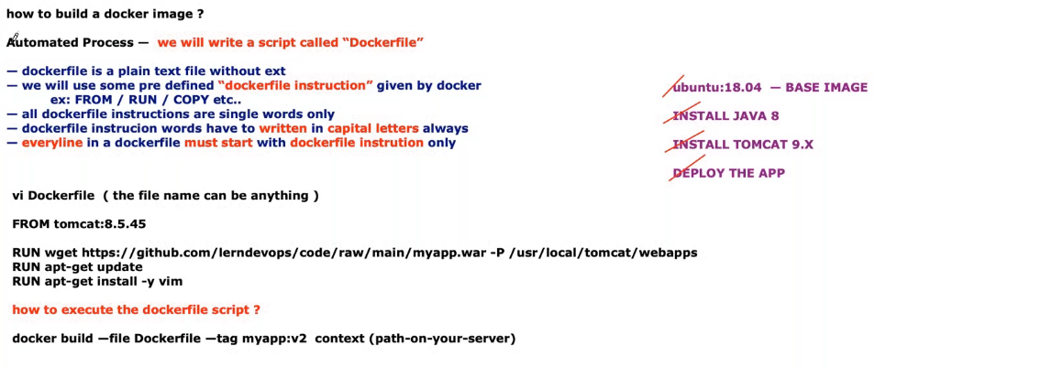
nano Dockerfile
FROM tomcat:8.5.46 # pull the image, run as container, login into the container
RUN apt-get update
RUN apt-get install -y vim
RUN wget https://github.com/lerndevops/code/raw/main/sampleapp.war -P /usr/local/tomcat/webapps
docker build -f Dockerfile --tag sampleapp:v2 /root # in which directory Dockerfile available
docker image ls
docker run -d -P sampleapp:v2

UC2:
step1: download tomcat, jdk, myapp.war in root directory
step2: nano myapp
FROM ubuntu:18.04 # pull the image, run as container, login into the container
# ADD instruction extracts/unzips the tar/zip files and copies the extracted contents to container
ADD jdk-8u331-linux-x64.tar.gz /tmp
RUN mv /tmp/jdk1.8.0_331 /opt/java
ADD apache-tomcat-9.0.63.tar.tz /tmp
RUN mv /tmp/apache-tomcat-9.0.63 /opt/tomcat
ENV JAVA_HOME /opt/java
ENV TOMCAT_HOME /opt/tomcat
ENV JAVA_VERSION 1.8
ENV TOMCAT_VERSION 9.0.63
COPY myapp.war /opt/tomcat/webapps/
# ADD Instruction can also be used to download the file from given URL
# RUN wget https://github.com/lerndevops/code/raw/main/sampleapp.war -P #/usr/local/tomcat/webapps
#ADD https://github.com/lerndevops/code/raw/main/sampleapp.war /opt/tomcat/webapps
# docker image inspect tomcat:9.0.63, sets the default port for the container that it helps docker to #publish the ports when you use -P
EXPOSE 8080
# The purpose of whole image creation is to start tomcat process when someone run the image
#helps to set default command for a image to execute when someone run image as container
CMD [“/opt/tomcat/bin/catalina.sh”,”run”]
docker build -f myapp --tag myapp:v1 /root
docker image ls
docker run -d -P myapp:v1
difference between ADD and COPY?
docker image ls
A Dockerfile is set of predefined instructions given by docker, which are used to construct a Docker Image. These instructions are called directives.
Instead of you run the instructions, docker executes the instructions on your behalf.
automate process: We will write a script called "Dockerfile"
1)Dockerfile is a plain text file without any extension
2) We will use some pre-defined Dockerfile instructions given by docker.
3)Dockerfile instruction is a single word and must be written in CAPITAL letters.
4) Every line in Dockerfile must start with Dockerfile instruction only:
vi Dockerfile # file name can be anything
FROM tomcat:8.5.40 # <accountid>/repository/tag
COPY target/sampleapp.war /usr/local/tomcat/webapps
EXPOSE 8080
CMD /usr/local/tomcat/bin/catalina.sh run
RUN touch /tmp/neeraj.txt
docker build -f Dockerfile --tag newimage:tag /root
Dockerfile directive:
FROM: start a new build stage and sets the base image, usually, must be the first directive in the Dockerfile (except ARG can be placed before FROM).
RUN: creates a new layer on top of the previous layer by running a command inside that new layer and committing the changes.
give instructions to the docker, docker runs these instructions within the container while preparing an image.

COPY: copy files from the local machine to the image.
ADD: same as COPY, additionally It can also copy files and directory from remote URL and also can copy the .tar file inside the container untar it in one shot.
CMD: default instruction Will be executed when container start from the given image, if someone wants to overwrite, the CMD instruction defined in the docker file, can be done at run time by passing another CMD.
We can pass it as an argument to the ENTRYPOINTS, CMD Instruction is a default argument to the ENTRYPOINT Instruction.
If there are more than 1 CMD then last will override previously CMD.
docker run <ubuntu> [command]
docker run ubuntu sleep 5 # default bash (process listen to terminal)
CMD [“sleep”,”5”] # first parameter must be executable
ENTRYPOINT: Is also run time instruction just like CMD instruction, we cannot overwrite the ENTRYPOINT instruction, if we trying at run time then newly command will be appended with the EntryPoint.
The ENTRYPOINT specifies a command that will always be executed when the container starts. The CMD specifies arguments that will be fed to the ENTRYPOINT.
Both CMD and ENTRYPOINT instructions define what command gets executed when running a container. There are few rules that describe their co-operation.
Dockerfile should specify at least one of CMD or ENTRYPOINT commands.
FROM Ubuntu
ENTRYPOINT [“sleep”]
In case of CMD instruction the command line parameter passed will gets replaced entirely, while in case of ENTRYPOINT command line parameters gets appended.
FROM Ubuntu
ENTRYPOINT [“sleep”]
CMD [“5”]
EXPOSE: 8080 documents which port(s) are intended to published when running a container. Docker understand container running on which port
ENV: set environment variables. These can be referenced in the Dockerfile itself and are visible to the container at runtime.
WORKDIR: sets the current working directory, you can also use relative path, which sets the new working directory relative to the previous working directory.
STOPSIGNAL: specify the signal that will be used to stop the container.
HEALTHCHECK: specify a command to run in order to perform a custom health check to verify that the container is working properly.
/*
https://mirrors.estointernet.in/apache/tomcat/tomcat-9/v9.0.40/bin/apache-tomcat-9.0.40.tar.gz
FROM ubuntu
RUN apt-get -y update
RUN apt-get -y install openjdk-11-jdk wget
RUN mkdir /opt/tomcat
ADD apache-tomcat-9.0.40.tar.gz /tmp
RUN mv /tmp/apache-tomcat-9.0.40/* /opt/tomcat/
COPY myapp.war /opt/tomcat/webapps
EXPOSE 8080
ENTRYPOINT ["/opt/tomcat/bin/catalina.sh", "run"] ## JSON Format */
Layered Architecture
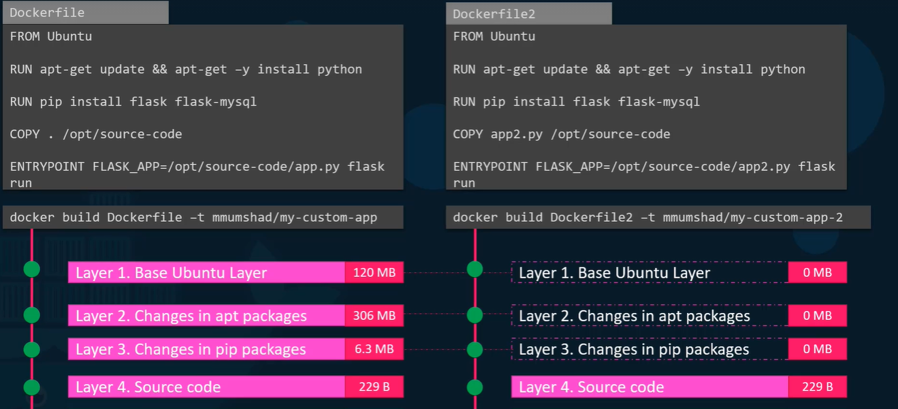
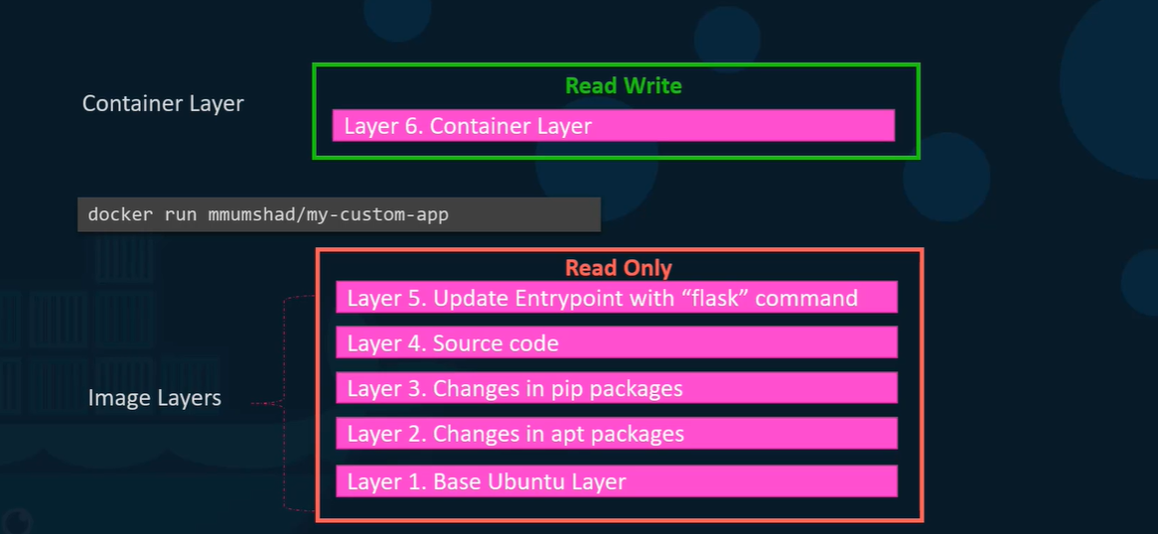
Each layer is a command, when its executed, creates intermediary image.

Docker Multistage Builds (Smaller Docker Image)
- Use Smaller base image
- Reduce the size of each layer
- Reduce number of layers
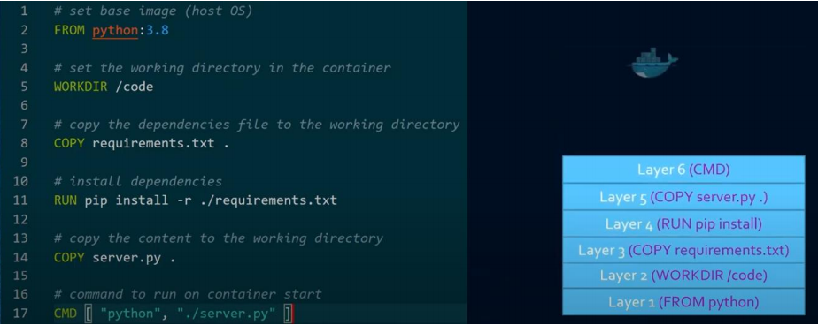
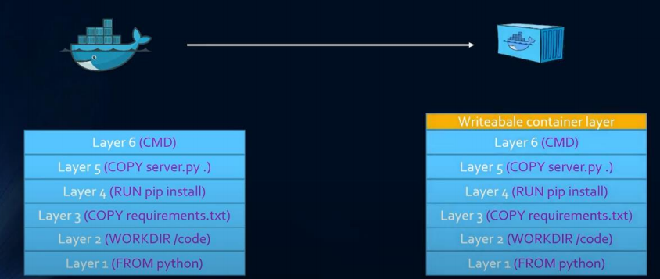
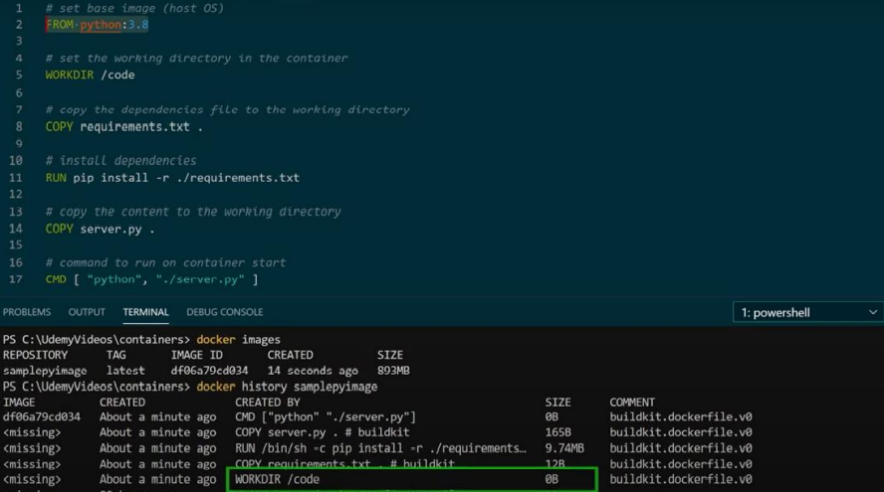
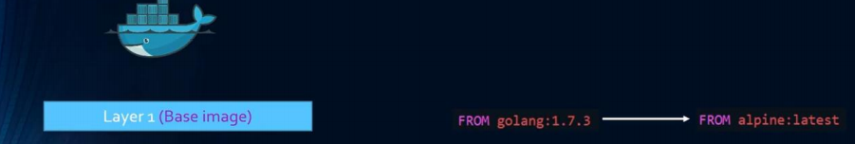
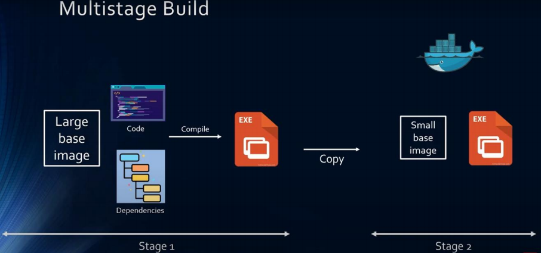
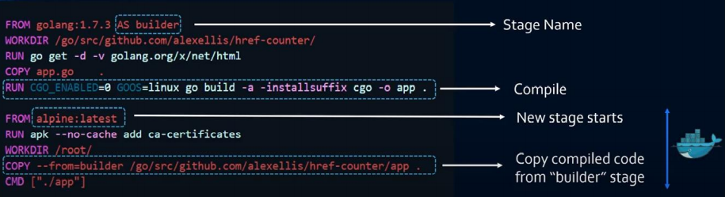
Who is responsible to maintain the layered architecture?
UnionFS is a filesystem service which is used for creating docker image layer.
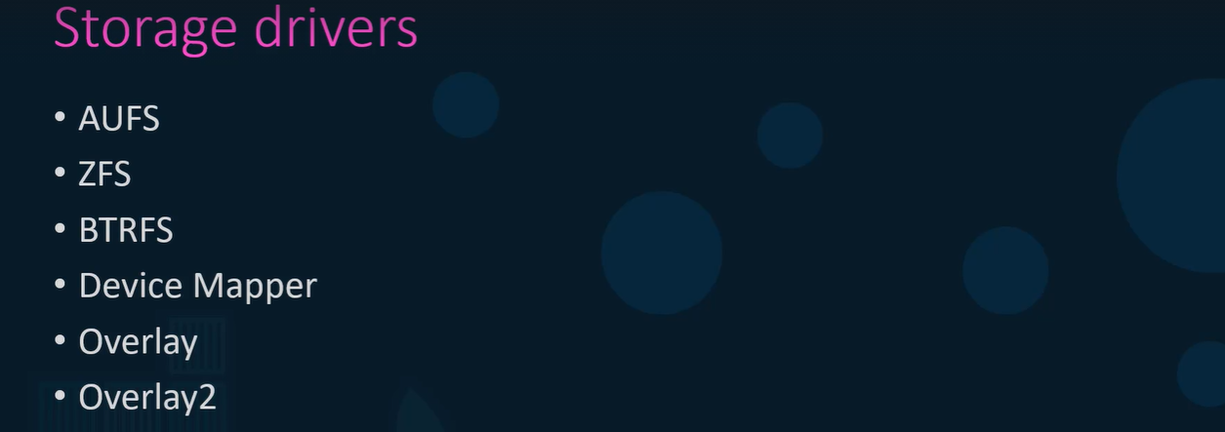
command in containers in Docker
UC1: you are running Ubuntu container
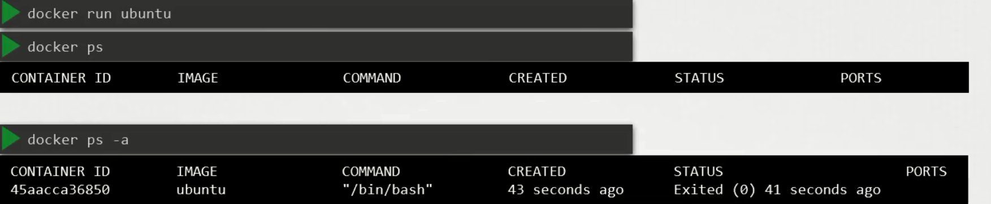
Unlike a VM containers are not meant to host an O/S, containers are meant to host specific task or process, such as to host an Instance of the webserver, an instance of an application server or db server instance or to carry out some computation.

Once the task is over container exits. Container lives only till process inside it alive, if the webservice inside the container stops or crashes the container exits.
Who defines what process runs inside the container?
Ubuntu Image uses a bash as the default command, but bash is not really a process like a webserver or the database server, it’s a shell that listens for input from a terminal , if it can not find the terminal it exits. When we ran the ubuntu container docker run ubuntu docker creates a container from ubuntu image and launch the bash program, by default docker doesn’t attach a terminal to a container when its is run, so that bash program doesn’t find a terminal so that it exits. Since the process that was started when the container was created finished the container exits as well.
How to specify a different command to start the container?
Option1: append the docker run command
It will overwrite the default command specified with in the image.
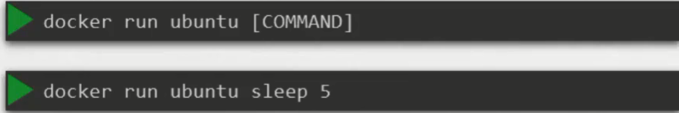
In this case when container will start, it will execute the sleep program and then exits.
UC: How to make this change permanent say you want image always run the sleep program when it starts?
You have to create your own image from the base ubuntu image and specify your own CMD
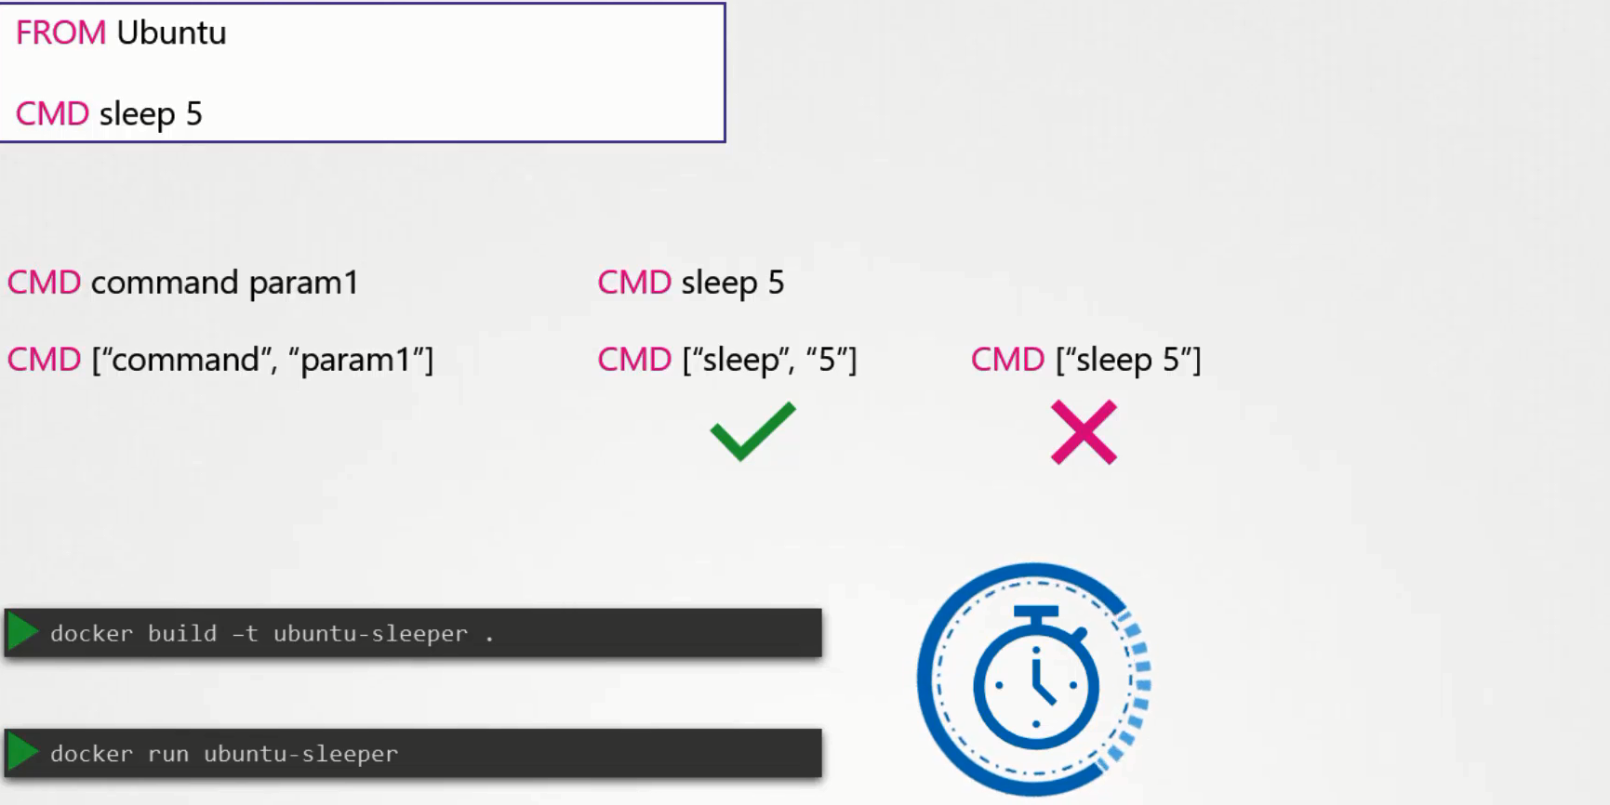
Remember whenever you create in JSON format first parameter must be executable.
UC: Want to change the number of seconds it sleeps currently its hard coded for 5 sec?
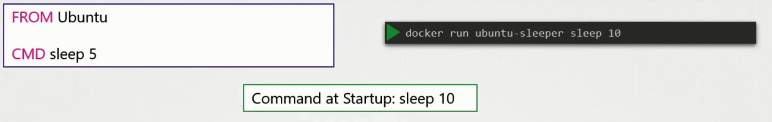
But we want to pass only the number of seconds, and sleep command must be invoked automatically

ENTRYPOINT instruction is like a command instruction, you can specify the program that will be invoked when the container starts. Whatever you will specify in ENTRYPOINT will automatically appended when you run the container.
In case of CMD instruction the command line parameter passed will gets replaced entirely, while in case of ENTRYPOINT command line parameters gets appended.
UC: What will happen if in second case will run the command without append the number of seconds?
Then the command at the start-up will be sleep and we get the exception “missing operand”
UC: How to define the default value for the command line instrunction?
You have to define ENTRYPOINT and CMD in JSON format
FROM ubuntu
ENTERYPOINT [“sleep”]
CMD [“5”]
UC: How to overwrite the ENTRYPOINT instruction?
docker run –entrypoint sleep2.0 ubuntu-sleep
How to transfer images to another machine?
- Dockerhub -> push your image to remotely publicly accessible repository
- ECR -> Elastics container Registry
- Offline

How to publish docker image to dockerhub/ How to share image available in local server?
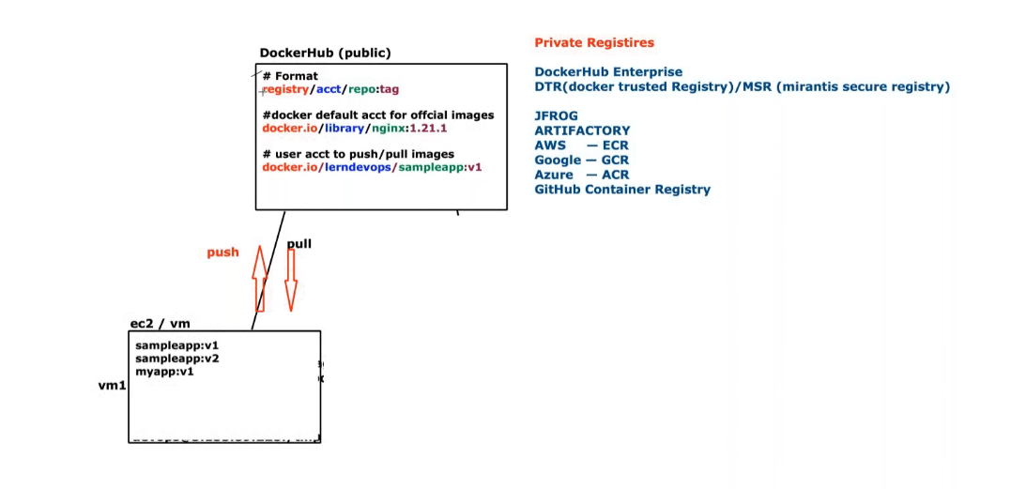
docker pull gcr.io/google-containers/busybox:1.27
docker push # default [docker.io/library/repo]
docker build -f myapp --tag docker.io/neerajvohra/ learningjourney:myapp-v1 /root
# docker build -f Dockerfile --tag docker.io/neerajvohra/ learningjourney:myapp-v1 /root
docker image ls
docker login neerajvohra
# docker login gcr.io
# docker push neerajvohra/learningjourney:tagname
docker push docker.io/neerajvohra/learningjourney:myapp-v1
docker tag docker.io/library/tomcat:8.5.45 docker.io/neerajvohra/learningjourney:tomcat8.5.45
docker images # docker image ls
step1: Go to dockerhub create an account.
step2: Create a repository.
step3: come to your command line.
step4: docker login # default try for docker hub
# docker login jfrog.com/useraccount/repository
step5: Once successfully connected to the dockerhub.
step6: docker push sampleapp: v3 # denied
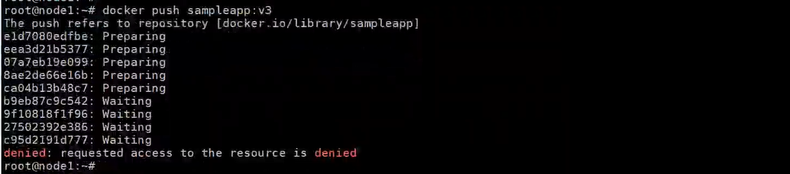
# [docker.io/library (default docker account)/sampleapp]
step7: docker tag sampleapp:v3 <accountname>/<repository>: <image>
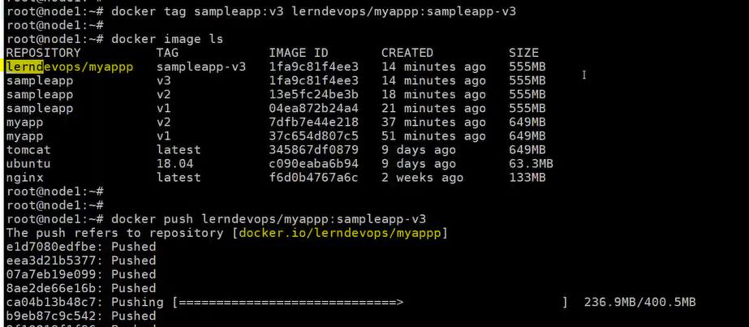
How to push image in private repository?
- Default remote is dockerhub (URL of JFrog)
- Default account is docker (Your Account)
- Default repository (Your Repository: Image)
docker tag <image name> <jFrog Id>/<account name>/<repository name>: tag
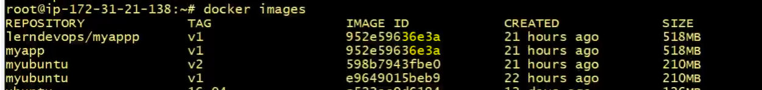
UC: How UC: transfer the image from one environment to another environment without remote repository.
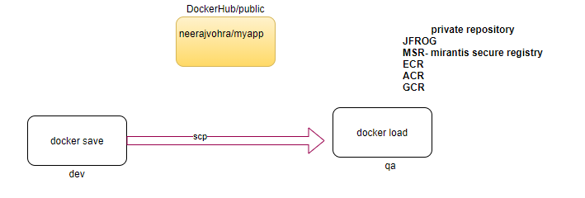
step1: convert the image to .tar file (image is not a file its file system, we can’t use scp command)
docker save -o myimages.tgz sampleapp: v3 sampleapp: v2 sampleapp: v2
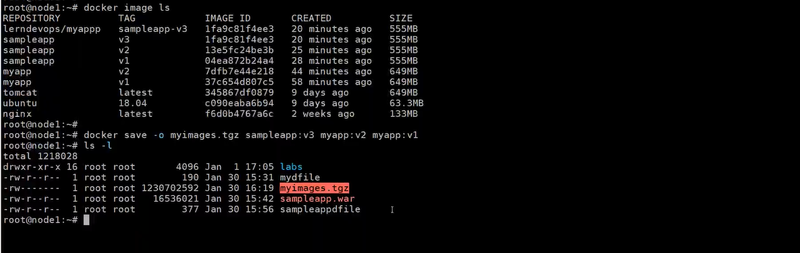
step2: transfer the .tar file
scp myimages.tgz devops@10.128.0.18:/tmp
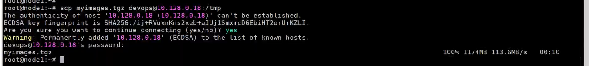
step3: login into target machine
cd /tmp
docker load < myimages.tgz
